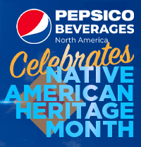 | Polly Pepsi  Manager  PepsiCo Beverages North America  Marketing  1111 Westchester Avenue, White Plains, NY 10604 914.123.9876 (O)  Email: polly.pepsi@pepsico.com  Pronouns: She/ Her

